**Plugging into the Future: An Exploration of Electricity Consumption Patterns Using Tableau**

**Project Description:**  
Plugging into the Future: An Exploration of Electricity Consumption Patterns using Tableau" is a project that leverages Tableau's data visualization capabilities to analyze and understand electricity consumption patterns across various regions and sectors. By examining data such as time-of-day usage, peak demand periods, seasonal variations, and consumption by sector (residential, commercial, industrial), the project aims to provide valuable insights for utility companies, policymakers, and consumers. These insights can help optimize electricity usage, improve grid management, and promote sustainable energy practices.

Scenario 1: Time-of-Day Usage Patterns

The visualization tool allows users to explore electricity consumption trends throughout the day, across different regions and sectors. By identifying peak usage times and low-demand periods, utility companies can better manage electricity supply and demand, and design incentives for off-peak usage.

Scenario 2: Seasonal Variations and Forecasting

The project uses Tableau to analyze seasonal variations in electricity consumption patterns. Understanding how usage fluctuates throughout the year can help stakeholders plan for seasonal peaks and troughs, ensuring reliable power supply and optimizing energy production from renewable sources.

Scenario 3: Sector-Specific Consumption Insights

Through data visualization, the project explores electricity consumption by different sectors such as residential, commercial, and industrial. This analysis can reveal which sectors are the largest consumers of electricity and how their usage patterns differ. Utility companies can use this information to tailor conservation programs and energy efficiency initiatives to specific sectors for more effective energy management.

**Project Flow**

To accomplish this, we have to complete all the activities listed below,

* Define Problem / Problem Understanding
  + Specify the business problem
  + Business requirements
  + Literature Survey
  + Social or Business Impact.
* Data Collection & Extraction from Database
  + Collect the dataset,
  + Storing Data in DB
  + Perform SQL Operations
  + Connect DB with Tableau
* Data Preparation
* Prepare the Data for Visualization
* Data Visualizations
  + No of Unique Visualizations
* Dashboard
  + Responsive and Design of Dashboard
* Story
  + No of Scenes of Story
* Performance Testing
  + Amount of Data Rendered to DB ‘
  + Utilization of Data Filters
  + No of Calculation Fields
  + No of Visualizations/ Graphs
* Web Integration
  + Dashboard and Story embed with UI With Flask
* Project Demonstration & Documentation
  + Record explanation Video for project end to end solution
  + Project Documentation-Step by step project development procedure

**Data Collection & Extraction from Database**

Data collection is the process of gathering and measuring information on variables of interest, in an established systematic fashion that enables one to answer stated research questions, test hypotheses, and evaluate outcomes and generate insights from the data.

**Collect the dataset**

Please use the link to download the dataset:    
<https://drive.google.com/file/d/1JxIkHNwXxjFztKq7ad0_KtkukCqTckNy/view?usp=sharing>  
  
Activity 1.1: Understand the data  
  
In Dataset Consumption.csv data is in the form of a time series for a period of 24 months beginning from 2nd Jan 2019 till 5th December 2020. Columns contains States, Regions, Latitude, Longitude, Dates andUsage. The dataset has been scraped from the weekly energy reports of POSOC.  
Fields Include   
States - Indian States  
Regions- States in Regions on Indian Map  
Latitude - States in Regions on Indian Map  
Longitude - Geographical Coordinates of States  
Dates - Dates of Usage  
Usage - Power consumed in Mega Units(MU)

**Storing Data in DB & Perform SQL Operations**

**Explanation video link:**

<https://drive.google.com/file/d/1FvnGQo9cNBfAjyRSiKC_6DG9_6x5ohuG/view?usp=sharing>

Consumption.csv - Google Drive..

No description..

<https://drive.google.com/file/d/1JxIkHNwXxjFztKq7ad0_KtkukCqTckNy/view?usp=sharing>

**Storing Data in DB & Perform SQL Operations**

**Explanation video link:**

<https://drive.google.com/file/d/1FvnGQo9cNBfAjyRSiKC_6DG9_6x5ohuG/view?usp=sharing>

Electricity Sql.mp4 - Google Drive..

No description..

<https://drive.google.com/file/d/1FvnGQo9cNBfAjyRSiKC_6DG9_6x5ohuG/view?usp=sharing>

**Connect DB with Tableau**

**Explanation video link:**

<https://drive.google.com/file/d/1ssm30WD0EXOVwXPwMCWqrEbBieZlV3t6/view?usp=sharing>

Database Integration.webm - Google Drive..

No description..

<https://drive.google.com/file/d/1ssm30WD0EXOVwXPwMCWqrEbBieZlV3t6/view?usp=sharing>

**Data Preparation**

Preparing the data for visualization involves cleaning the data to remove irrelevant or missing data, transforming the data into a format that can be easily visualized, exploring the data to identify patterns and trends, filtering the data to focus on specific subsets of data, preparing the data for visualization software, and ensuring the data is accurate and complete. This process helps to make the data easily understandable and ready for creating visualizations to gain insights into the performance and efficiency.  
  
This data is preprocessed initially. Lets proceed for visualization.

**Data Visualization**

Data visualization is the process of creating graphical representations of data in order to help people understand and explore the information. The goal of data visualization is to make complex data sets more accessible, intuitive, and easier to interpret. By using visual elements such as charts, graphs, and maps, data visualizations can help people quickly identify patterns, trends, and outliers in the data.

**No of Unique Visualizations**

The number of unique visualizations that can be created with a given dataset. Some common types of visualizations that can be used to analyze the performance and efficiency of Radisson Hotels include bar charts, line charts, heat maps, scatter plots, pie charts,Maps etc. These visualizations can be used to compare performance, track changes over time, show distribution, and relationships between variables, breakdown of revenue and customer demographics, workload, resource allocation and location of hotels.  
  
Activity 1.1: To Understand-2019 and 2020 Consumption, Total Consumption, Usage by Region, Top N and Bottom N States  
Explanation video link: <https://drive.google.com/file/d/1pVHAOm5Z_5mJlEeVTH232l_dXE38W0eB/view?usp=sharing>  
  
  
Activity 1.2: To Understand-2019 and 2020 Month wise Consumption, Total Consumption by region, Usage Before and After Lockdown  
Explanation video link: <https://drive.google.com/file/d/1MEthsJ89teEYR6k688W-7i5Bk0dEBIo2/view?usp=sharing>  
  
Activity 1.3:  To understand  Region wise State Usage Quarter Usage and Usage by Year  
Explanation video link: <https://drive.google.com/file/d/1utqB_EInIi2AFb4tT7Nr2RSsznRVe5Ty/view?usp=sharing>

**Dashboard**

A dashboard is a graphical user interface (GUI) that displays information and data in an organized, easy-to-read format. Dashboards are often used to provide real-time monitoring and analysis of data, and are typically designed for a specific purpose or use case. Dashboards can be used in a variety of settings, such as business, finance, manufacturing, healthcare, and many other industries. They can be used to track key performance indicators (KPIs), monitor performance metrics, and display data in the form of charts, graphs, and tables.

**No of Unique Visualizations**

The responsiveness and design of a dashboard for analyzing the performance and efficiency of Radisson Hotels is crucial to ensure that the information is easily understandable and actionable. Key considerations for designing a responsive and effective dashboard include user-centered design, clear and concise information, interactivity, data-driven approach, accessibility, customization, and security. The goal is to create a dashboard that is user-friendly, interactive, and data-driven, providing actionable insights to improve the performance and efficiency of Radisson Hotels.  
Once you have created views on different sheets in Tableau, you can pull them into a dashboard.  
  
Explanation video link: <https://drive.google.com/file/d/1xBAJZD7TGEMzssDpHlrjmTS6GiaNzPHE/view?usp=sharing>  
  
                    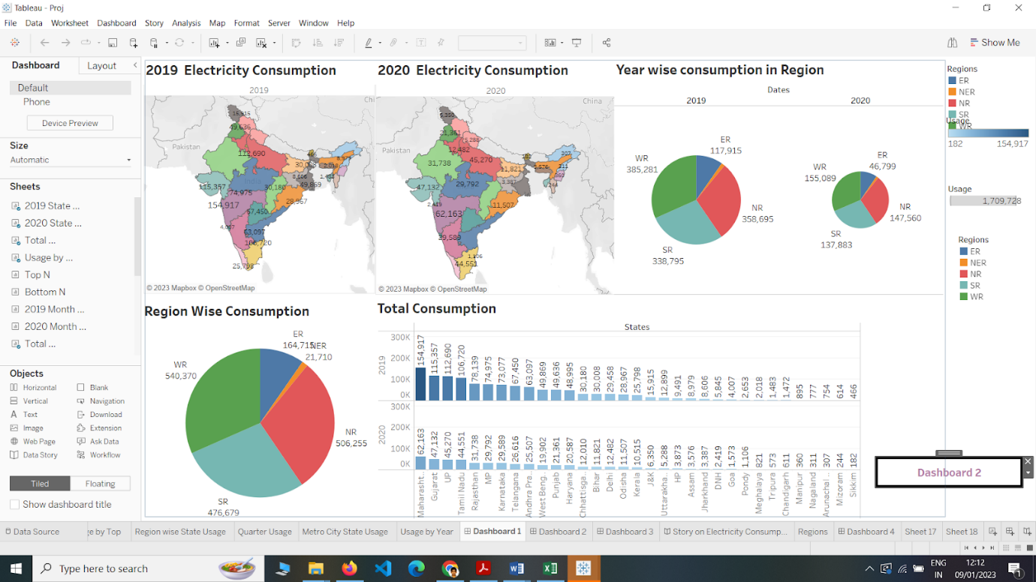

Dashboard Creation.mp4 - Google Drive..

No description..

<https://drive.google.com/file/d/1xBAJZD7TGEMzssDpHlrjmTS6GiaNzPHE/view?usp=sharing>

**Story**

A data story is a way of presenting data and analysis in a narrative format, with the goal of making the information more engaging and easier to understand. A data story typically includes a clear introduction that sets the stage and explains the context for the data, a body that presents the data and analysis in a logical and systematic way, and a conclusion that summarizes the key findings and highlights their implications. Data stories can be told using a variety of mediums, such as reports, presentations, interactive visualizations, and videos.

**Responsive and Design of Dashboard**

The number of scenes in a storyboard for a data visualization analysis of the electricity consumption in india will depend on the complexity of the analysis and the specific insights that are trying to be conveyed. A storyboard is a visual representation of the data analysis process and it breaks down the analysis into a series of steps or scenes.  
Explanation video link:   
<https://drive.google.com/file/d/1qxEL-SCEc_yoM9wDOJXj9hIHxgoG25gO/view?usp=sharing>  
  
             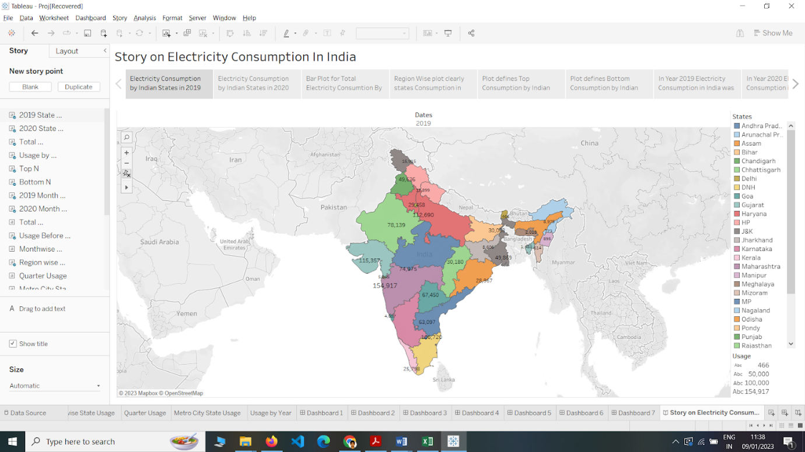

Story Creation.mp4 - Google Drive..

No description..

<https://drive.google.com/file/d/1qxEL-SCEc_yoM9wDOJXj9hIHxgoG25gO/view?usp=sharing>

**Performance Testing**

**Amount of Data Rendered to DB**

The amount of data that is rendered to a database depends on the size of the dataset and the capacity of the database to store and retrieve data.   
Open the MySQL Workbench, go to the database then click to expand the tables, select the table and click on (i) button to get the information related to table such as column count, table rows etc.  
  
                        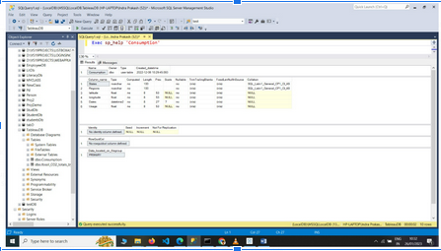

**Utilization of Data Filters**

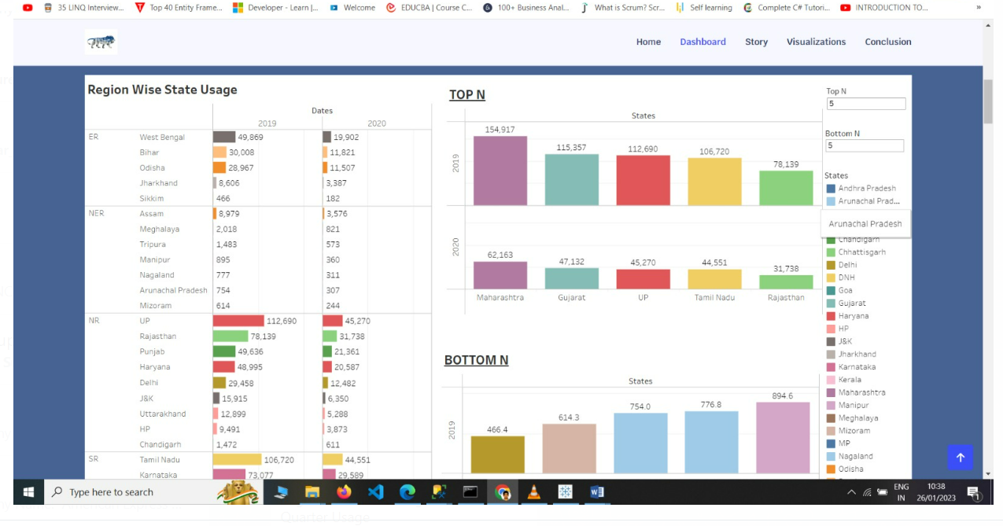

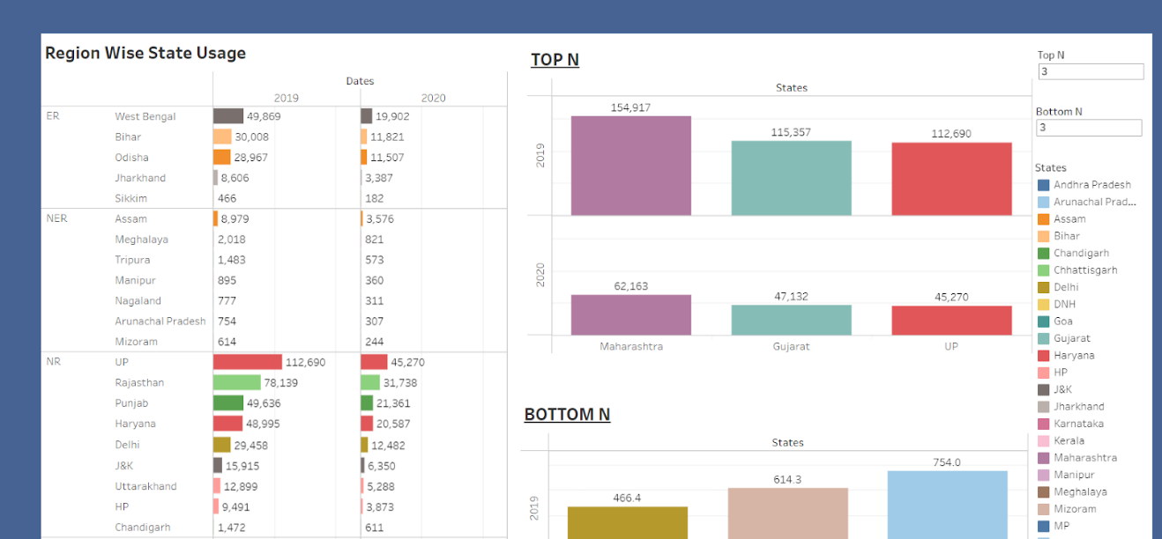

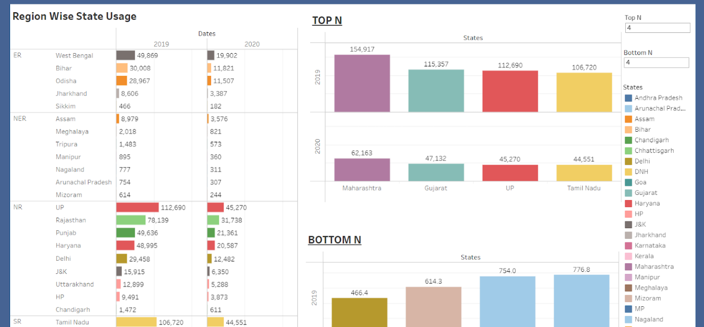

**No of Visualizations/ Graphs**

1. 2019 State Consumption
2. 2020 State Consumption
3. Total Consumption
4. Usage By Region
5. Top N and Bottom N
6. 2019 and 2020 Monthwise Consumption
7. Total Consumption Region Wise
8. Usage Before and After Lockdown
9. Region wise State Usage
10. Quarter Usage
11. Metro city  State usage
12. Usage by year

**Web integration**

Publishing helps us to track and monitor key performance metrics, to communicate results and progress. help a publisher stay informed, make better decisions, and communicate their performance to others.  
Publishing dashboard and reports to tableau public  
  
Step 1: Go to Dashboard/story, click on share button on the top ribbon  
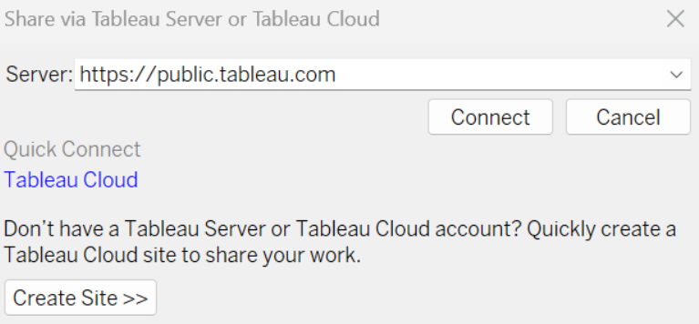  
  
Step 2: Once you click on connect it will ask you for tableau public user name and password  
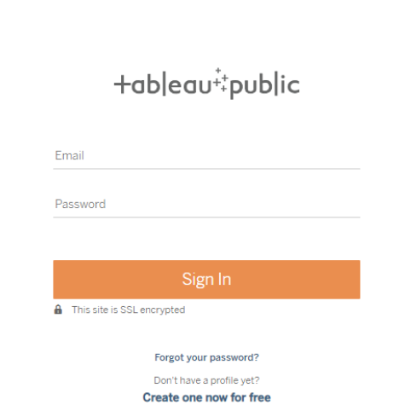  
Once you login into your tableau public using the credentials, the particular visualization will be published into tableau public  
Note: While publishing the visualization to the public, the respective sheet will get published when you click on share option.

**Dashboard and Story embed with UI With Flask**

**Explanation video link 1:** <https://drive.google.com/file/d/1hvXhX09fEFC7gqXSGdDY-yS7ghbZgp9S/view?usp=sharing>

**Explanation video link 2:** https://drive.google.com/file/d/180H5eFsCSr02qyDigEOt1yZLdmZYL0gi/view?usp=sharing

**Direct through Template Shared:** <https://drive.google.com/file/d/1lArZYEqZW2VLkhLYxJ0Rkogpq8grgB1i/view?usp=sharing>

**Using Flask :** <https://drive.google.com/file/d/1SFf8HNGkrEjFNbmtOmMPLsShTpy8hI_7/view?usp=sharing>

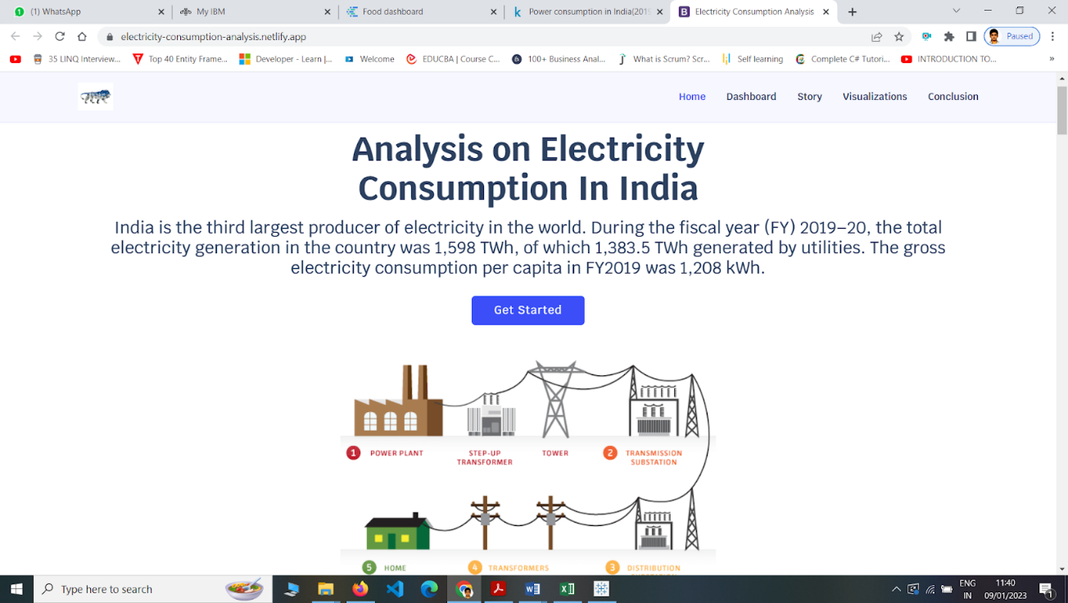

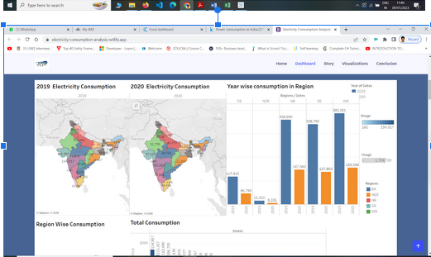

                             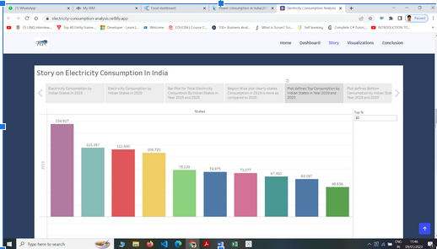  
                            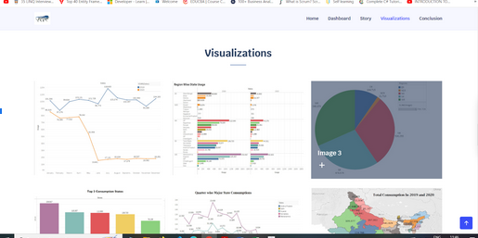

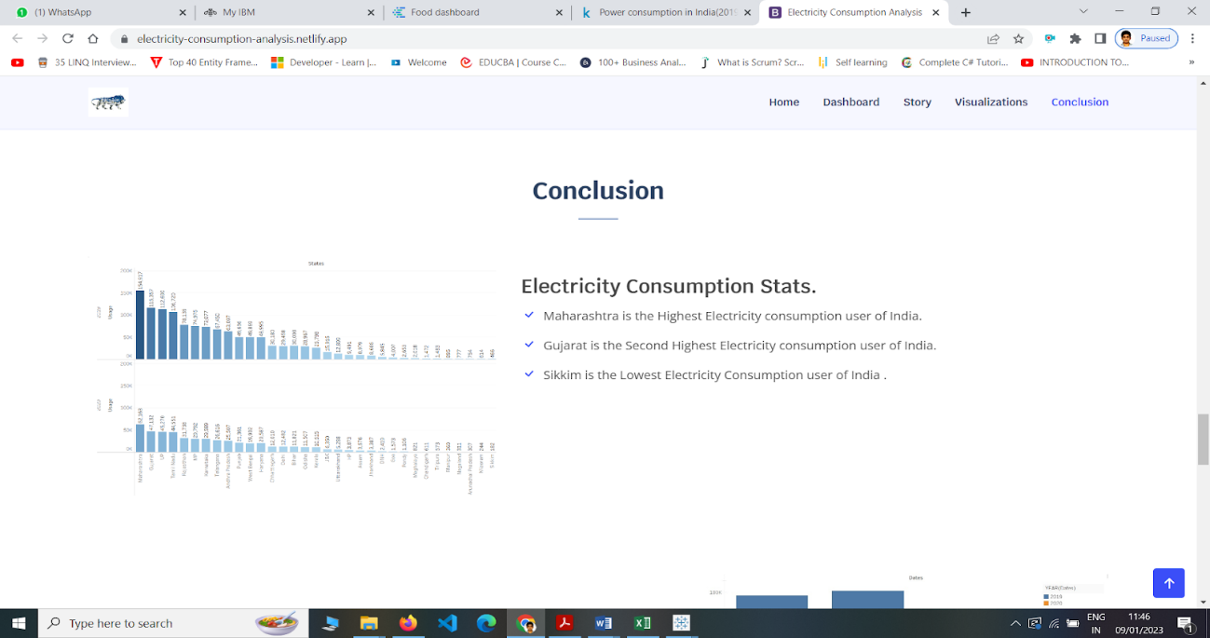

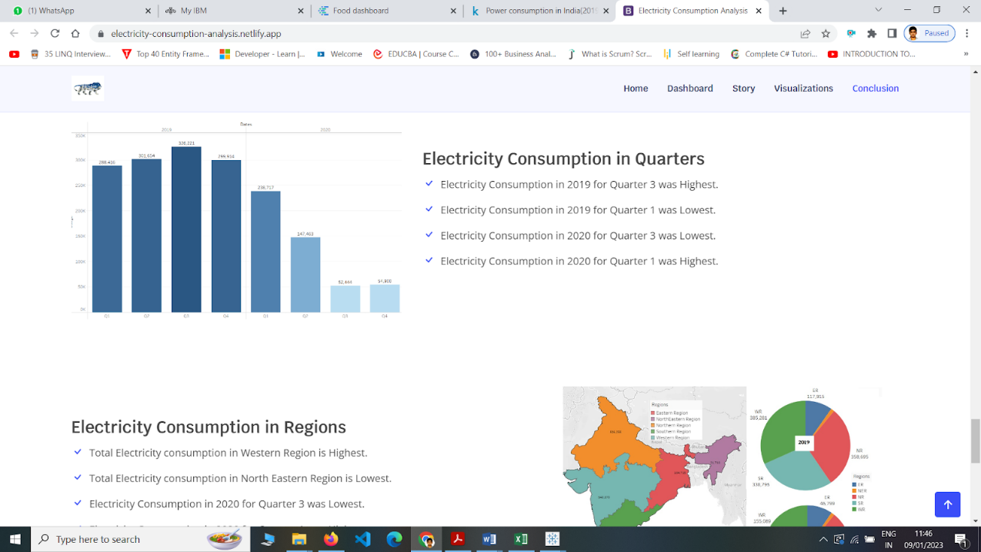

Publishing.mp4 - Google Drive..

No description..

<https://drive.google.com/file/d/1hvXhX09fEFC7gqXSGdDY-yS7ghbZgp9S/view?usp=sharing>

Tableau Web Integration.mp4 - Google Drive..

No description..

<https://drive.google.com/file/d/180H5eFsCSr02qyDigEOt1yZLdmZYL0gi/view?usp=sharing>

Web Integration2.mp4 - Google Drive..

No description..

<https://drive.google.com/file/d/1lArZYEqZW2VLkhLYxJ0Rkogpq8grgB1i/view?usp=sharing>

Flask Web Integration.mp4 - Google Drive..

No description..

<https://drive.google.com/file/d/1SFf8HNGkrEjFNbmtOmMPLsShTpy8hI_7/view?usp=sharing>

**Project Demonstration & Documentation**

Below mentioned deliverables to be submitted along with other deliverables  
Activity 1:- Record explanation Video for project end to end solution  
Activity 2:- Project Documentation-Step by step project development procedure  
  
Create document as per the template provided